HKU Business School
MSBA7024 Database Design and Management
Written Exam

Name:

University Number:

Please note the following:
1. You should type your answers directly in the exam question file in Word format. Do NOT print out the exam and write you answers by hand. Upload this file (in Word or PDF format) with your answers at the end of the exam.
2. The exam is semi-open book:
- You are only allowed to refer to your lecture notes and assignments either in printed version or digital version on your computer. You may also refer to any other notes that you have made yourself. Textbooks, either printed or digital, are NOT allowed.
- You are NOT allowed to open any apps or webpages other than the course Moodle and Zoom platform during the examination. For example, you are not supposed to go to the websites of MySQL and MongoDB to check query syntax, visit Wikipedia, or use any search engines. Besides Moodle and Zoom, the only exception is the online drawing tool discussed in Point (3) below.
3. For questions on ER diagrams, you may draw the ER diagrams in one of the following ways:
- You may use any software installed on your computer (including but not limited to the simple drawing/shapes tool in MS Word and Powerpoint). MS Visio is not recommended because it uses a different notation.
- You may use any online drawing tools, such as SmartDraw:
https://cloud.smartdraw.com/
Mac users can consider using this online tool if you do not have other tools installed.
- You may draw it on a piece of paper and then take a photo of it when you have informed the invigilator that you are ready to submit your exam. Do NOT use the phone in the middle of the exam (otherwise, it may be troublesome and time-consuming for you to set it up correctly again to continue your exam).
- You may also draw it on a tablet, e.g., an iPad, and then transfer the image to your computer.
In all the options above, you should copy and insert your drawing or image into your Word file. Do NOT submit the images as separate files.
4. You are NOT allowed to use MySQL, MongoDB, Python, or any other database systems or software on your computer or the Internet during the exam.
5. For questions on drawing the logical design of a table, you are suggested (but not mandatory) to use the following format:
RELATION_NAME(Primary_Key1, …, Attribute1, …, Foreign_Key1, …)
instead of drawing all the boxes like what was shown in the slides.
You are also required to draw arrows for foreign keys.

Please answer all 8 questions.

1. (15 points) ER Diagram
Draw an ER diagram for the following situation. If you believe that you need to make additional assumptions, clearly state them. Follow good data naming guidelines.

Each publisher has a unique name; a mailing address and telephone number are also kept on each publisher. A publisher publishes one or more books; a book is published by exactly one publisher. A book is identified by its ISBN, and other attributes are title, price, and number of pages. Each book is written by one or more authors; an author writes one or more books, potentially for different publishers. Each author is uniquely described by an author ID, and we know each author’s name and address. Each author is paid a certain royalty rate on each book he or she authors, which potentially varies for each book and for each author. An author receives a separate royalty check for each book he or she writes. Each check is identified by its check number, and we also keep track of the date and amount of each check.

Answer:

2. (15 points) Logical Design
Transform the following diagrams into relations. Your answer may be given in the “box format” as shown in the slides or the following format:
RELATION_NAME(Primary_Key1, …, Attribute1, …, Foreign_Key1, …)
Show the arrows for foreign keys.

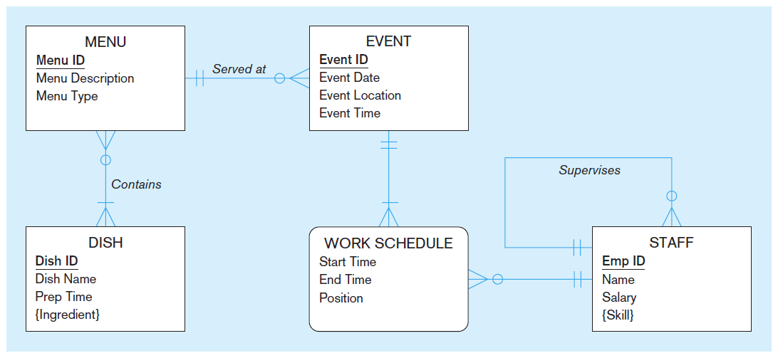

Answer:
3. (10 points) Functional Dependencies and Normal Forms
The following shows a relation called GradeReport with StudentID and CourseID as the primary key.
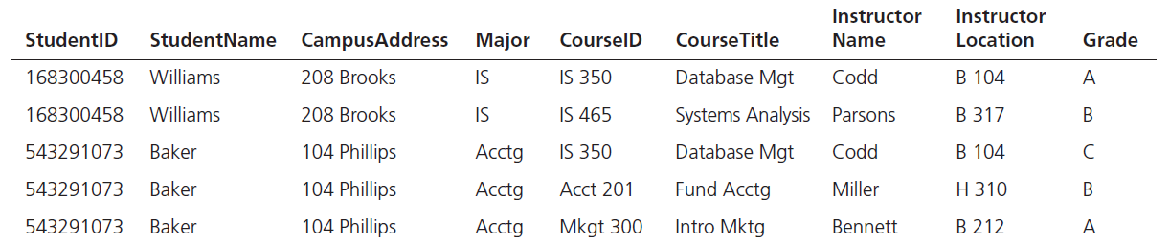

- Show the functional dependencies in the relation.

- In what normal form is this relation? Explain your answer.

- Decompose GradeReport into a set of 3NF relations.

Questions 4 and 5 are based on the class schedule problem shown in the following figure:

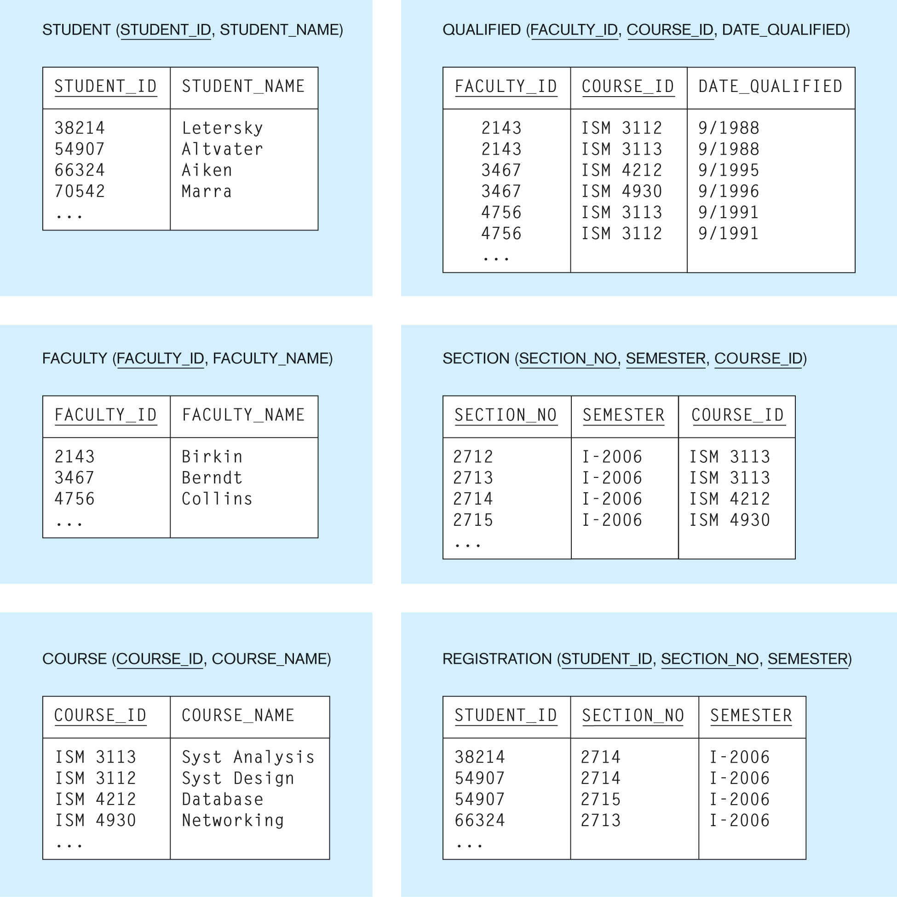

4. (15 points) Simple SQL
(a) Write an INSERT command to add a faculty member with a faculty ID of 2366 and name Culler to the FACULTY table.

(b) Write a command that will modify the name of course ISM 3113 from “Syst Analysis” to “System Analysis”.

Answer:

(c) Write a command that will create a table SOCIETY (Society_ID, Student_ID), in which Student_ID is a 5-digit number and Society_ID is a 3-digit number, and Student_ID is a foreign key from the STUDENT table.

Answer:

(d) List the ids of the students who are enrolled in each section in Semester I, 2006. Organize the students by the sections in which they are enrolled. In each section, sort the students by their student ids.

Answer:
(e) List the ids and the number of courses qualified of all faculty members who are qualified to teach at least three different courses.

Answer:
5. (10 points) SQL for Multiple Tables and Subqueries
(a) Display the id, name, and faculty name for all courses that Professor Birkin has been qualified to teach.

Answer:

(b) Display the names and ids of all students who were not enrolled in any courses during semester I-2006.

Answer:

6. (10 points) Data Warehouse
(a) What is a star schema? Why is it good for data warehousing?

Answer:

(b) What is the ETL process in data warehousing? Why is it important?

Answer:

7. (10 points) NoSQL
(a) Explain the differences between RDBMS and NoSQL

Answer:
•

(b) Discuss the conditions when NoSQL data models are preferred over traditional RDBMS models.

Answer:

8. (15 points) MongoDB
Suppose you have a collection called users in your MongoDB database and it has the following data:

name | age | gender | affiliation | city
Michael | 25 | M | HKU | Hong Kong
Evelyn | 20 | F |  | Sydney
Simon | 35 | M |  | Beijing
Gigi | 22 | F |  | Hong Kong

(a) Write a Mongo Shell command to insert a new document with the following data into the users collection:
Name: Jennifer; Age: 30; Gender: F

Answer:
(b) Write a Mongo Shell command to remove records with the name Gigi from the collection.

Answer:

(c) Write a Mongo Shell command to find the records of all users whose age is at least 30.

Answer:

(d) Write a Mongo Shell command to find the records of all female users who are in Sydney.

Answer:

(e) Write a Mongo Shell command to update the affiliation of Simon to HKU.

Answer:

--- End of Exam Paper ---

